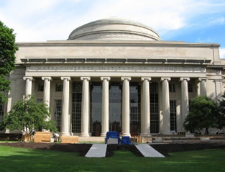

**RMW19**

**(OKABE60)**

**The 19th Workshop on Reactive Metal Processing**

**March 20 (Fri.) – 21 (Sat.), 2026 @ MIT, Cambridge**

(After TMS 2026, March 15 (Sun.) – 19 (Thu.), 2026 @ San Diego, California)

**Organizers:**

**Donald R. Sadoway**, *Massachusetts Institute of Technology*

**Toru H. Okabe**, *Institute of Industrial Science (IIS),*

*The University of Tokyo*

**Antoine Allanore**, *Massachusetts Institute of Technology*

**Shunsuke Yagi** *IIS, The University of Tokyo*

**Program Coordinators:**

**Takanari Ouchi**,*IIS*, *The University of Tokyo*

**Gavin Anthony Winter**,*Massachusetts Institute of Technology*

**Isaac Oda-Bayliss,** *IIS*, *The University of Tokyo*

**Nathan Daniel Bradshaw,** *Massachusetts Institute of Technology*

**Thananun Rattanamaneejarat** *IIS*, *The University of Tokyo*

Sponsors

* The Rare Metal Research Workshop, one of the Special Research Groups organized by the Foundation for the Promotion of Industrial Science (FPIS)   
  (RC-40: directed by Prof. T. H. Okabe, RC-104: directed by Prof. S. Yagi)
* Integrated Research Center for Sustainable Energy and Materials (SUSMAT)
* Institute of Industrial Science, The University of Tokyo (IIS UTokyo SYMPOSIUM No 123)

http://www.okabe.iis.u-tokyo.ac.jp/core-to-core/rmw